PROTEUS SCREENSHOTS OF LAB 4

TASK 1

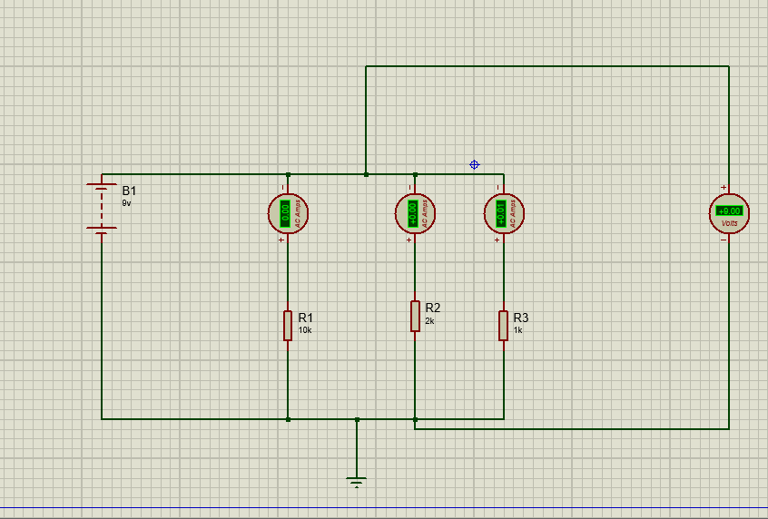

TASK 2
